Reviews from the MOVING IMAGES – OPEN BORDERS (MIOB) Third LAB of Cultural, Creative and Festival Journalism

From the European Film Forum SCANORAMA
November 9-19, 2023 in Vilnius, Lithuania

The Mammoth Task of Finding a Home Again
Aistė Stonytė’s documentary The Mammoth Hunt tells us about cultural disobedience in Lithuania under Soviet oppression and its consequences.
by Marlene Penn
In 1968, people from all over Lithuania stormed the Kaunas Drama Theater to witness something simultaneously outstanding and outrageous. Director Aistė Stonytė dedicates her documentary The Mammoth Hunt to exactly this happening – and everything that unfolded afterward.
The play of the same title by Jonas Jurašas sold out almost every night back in a time when cultural productions were subject to censorship by the Soviet oppressors. Despite being critical of the regime – luckily maybe too subtle at first glance – the piece played in Kaunas for over a year. One way or another, word about the controversial play reached the authorities which then immediately banned the performance.
Jurašas was left with the choice of fleeing the country or facing severe repercussions. He chose life and emigrated from the USSR to the USA. But before that, all the members of the production gathered one last time to do something dangerously courageous – they filmed the play.
However, the recordings later vanished. For seven years, it was Stonytė’s personal "mammoth" task to find out more about these reels and their disappearance. As the daughter of one of the participants in the original play (a detail absent from the film itself) she had a personal connection to the story. This may be the reason why the 94-minute documentary gradually loses its focus and presents us with two storylines with two different storytelling modes.
The first section revolves around the secret 16mm recording of the play and the unsuccessful attempt to recover these reels (a separate audio recording does exist). Interviews with Jurašas, the camera operators as well as other colleagues, friends, and collaborators should throw light on the matter. However, since it all happened fifty years ago, nobody remembers correctly – and each denies responsibility for initiating the filming.
The self-protection mechanism apparently still sits deep, and whoever knows about the whereabouts of the reels will probably take this secret to their grave. The editing by Audinga Kučinskaitė is particularly effective in this section, and sometimes even provides a touch of comic relief.
Stonytė then takes us on a different journey. We meet Jurašas as a man who was forced to leave home and returned to the newly independent Lithuania years later as a hero – only to learn that hardly anything about this country still felt like home to him.
The director manages to convey Jurašas’ internal struggle and the emotional complexity of his situation authentically and tangibly. However, a scene where Jurašas is overcome with emotion and cries on the stage of the theater breaks with the previously established credibility. This unfortunately comes across as a rather artificial and constructed sequence.
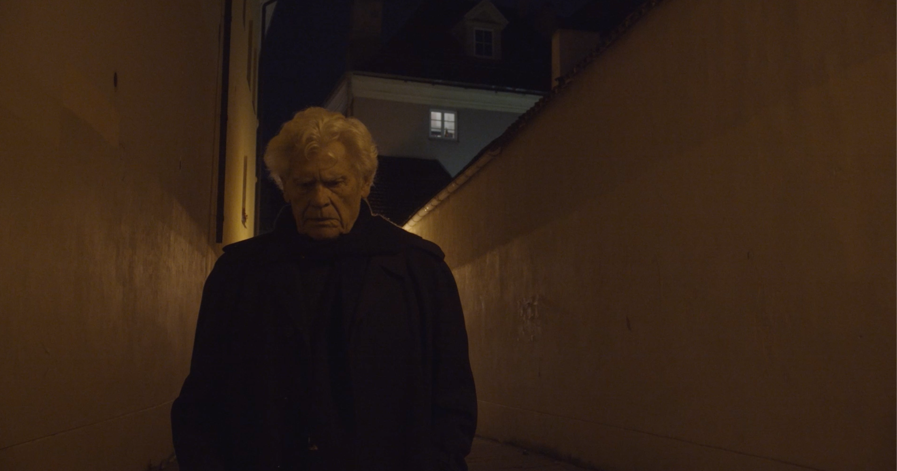
Stonytė tells an important story about the Lithuanian fight for independence and the role art played in that. However, her film would have had a clearer focus if it decided on one story. The struggle of (politically) expelled people and their perception of the home should have been allocated more time and space – especially if one fought for it the way that Jurašas and his companions so bravely did.

Reviews from the MOVING IMAGES – OPEN BORDERS (MIOB) Third LAB of Cultural, Creative and Festival Journalism

From the European Film Forum SCANORAMA
November 9-19, 2023 in Vilnius, Lithuania

Glimpses of Annihilated Life

Bianca Stigter’s documentary Three Minutes: A Lengthening brings a pre-Holocaust recording of Jewish life back to life and – more importantly – back into memory
by Marlene Penn
When David Kurtz filmed the Jewish residents of the Polish town Nasielsk in 1938, he did not know that one day his footage would be the only trace of their existence. Almost 75 years later, his grandson Glenn Kurtz recovered the reels and restored them – just in time, as the celluloid film was almost beyond repair. In the documentary Three Minutes: A Lengthening, director Bianca Stigter follows Kurtz’s dedicated attempt to identify the individuals seen in the film.
Kids fooling around, smiling young women, skeptical old men – the presence of Kurtz’s camera triggered different reactions in the 7,000-inhabitant town, of which almost half were Jewish. By 1945, fewer than 100 of them had survived the Holocaust. Only seven were still alive in 2012, and two of them are featured in the 1938 footage.
To discover this information, Kurtz conducts a broad and in-depth analysis of his grandfather’s material. He considers cultural, chemical, religious, geographical, biological, historical, linguistic, and fashion-related aspects of the about 150 featured people (and their environments) to identify their faces.
After extensive research, he finds one survivor who recognizes himself and others in the video. This contemporary witness takes the viewer back to those flashes of careless life before humiliation, deportation, and genocide. This also indirectly prompts the question of how accounting for the past will work when all witnesses have died.
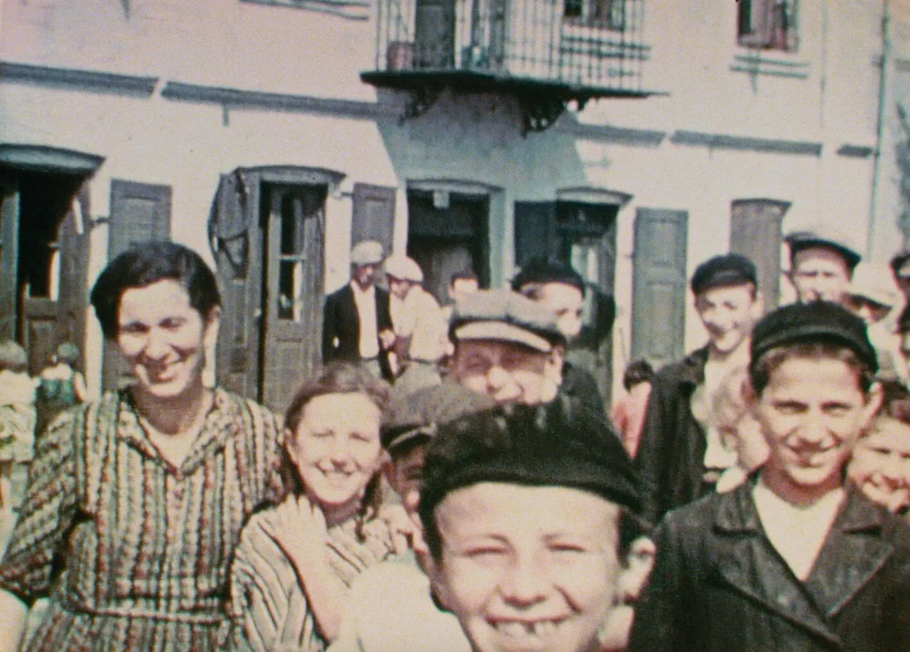
In her first film, Stigter makes the bold choice to only show those faces that really matter in that context – the ones of the Jewish people of Nasielsk. Neither narrators (including Helena Bonham Carter) nor interviewees are shown on screen so that the viewer is not distracted from the partly black-and-white, partly in-color shots. The director’s aim is to show that these humans really have existed and that they – at least now – deserve undivided attention and remembrance.
The film has a journalistic approach and effectively documents the historic reconstruction of those moments of life. Stigter is determined in what she wants the viewers to see or hear and what is to be excluded. The Nazis, for example, are given as little power and agency as possible, only referring to them as face- and nameless “they” or “them” in the voiceover.
The Jewish world of Nasielsk did not gradually fade away over time as the recordings did. Instead, it was radically wiped out by violence. This film brings back to life this lively town and its inhabitants – if only for the 69 minutes the film lasts.
Reviews from the MOVING IMAGES – OPEN BORDERS (MIOB) Third LAB of Cultural, Creative and Festival Journalism

From the European Film Forum SCANORAMA
November 9-19, 2023 in Vilnius, Lithuania

Brief Glimpses of Beauty
by Gijs Suy

In Vilnius' National Gallery of Art, Lithuanian-American filmmaker Jonas Mekas’ three-hour diary-movie Lost, Lost, Lost (1975) is on permanent display; one damp Saturday afternoon in November I watched the film for as long as my schedule allowed. Mekas’ camera effortlessly foregrounds the beautiful but wistful intermezzos that are often suppressed by the struggles of daily life.
Ptitsa (2022), Alina Maksimenko’s debut short — showing at the Scanorama film festival in the city — opens with a brief sequence shot on 8mm that recalls Mekas’ approach and foregrounds a similar feeling. Maksimenko’s documentary about her mother Tatiana and herself is a vivid exploration of brief moments of beauty shining through the firmament of their stress-infused existence.
The Polish production (Maksimenko's graduation-project at Wajda School) captures the duo cohabiting in a Kyiv apartment during the COVID-19 pandemic. She works on her paintings while Tatiana runs an online piano-school, following routines that are more or less separate. Maksimenko’s camera thorougly explores the spaces in which their quotidian existences take place, turning mundanity into something suggestive and interesting in a style reminiscent of the late Chantal Akerman. Maksimenko frequently uses frame-in-frame compositions, compressing the spaces in which the two women walk around and thus cutting them off from each other.
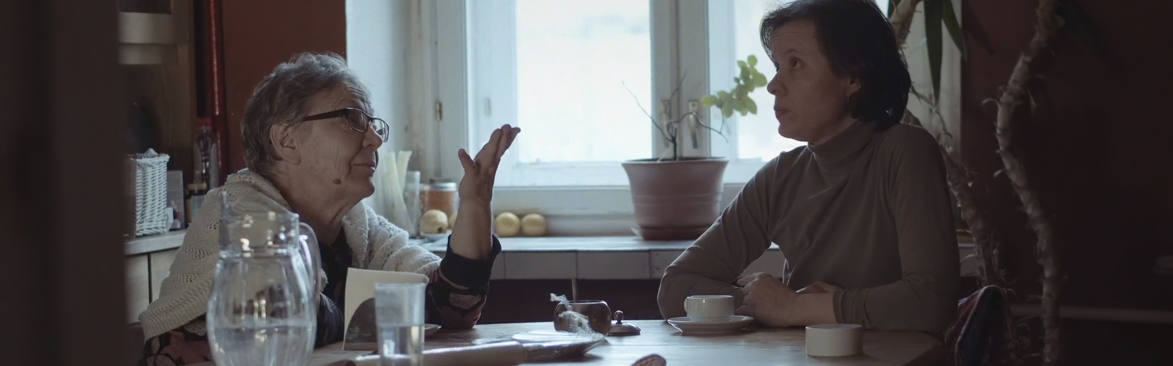
Physical distance is thematised in many other ways, such as the abundant use of mirrors and windows, which are often seen when Alina is talking on the phone to a friend she is unable to visit. The world surrounding them — which they almost exclusively perceive through the windows — becomes ghostlike.
Appearing through visual and aural impressions that scare and alienate them, the external realm pushes them back to the relative safety of their suffocating home. Another scene that expresses this idea of disconnect is when Tatiana listens to a heavily distorted song on her mobile phone, as if her connection to the outside is somehow muffled. Near the end of the film Tatiana and Alina do manage to find some form of relation to each other via the story of the friend's daughter's death. They use this to attribute some sense of meaning to their own lives.
Equally important, however, is when Tatiana discovers her daughter’s expressionist paintings and unleashes her vivid imagination, passionately enthusing about them. Ptitsa — which means "bird" — consistently holds both a grounded and an uplifting view of art. The protagonists are allowed to discover realities both inside and outside themselves, briefly detaching mother and daughter from the bleakness of their situation.
Reviews from the MOVING IMAGES – OPEN BORDERS (MIOB) Third LAB of Cultural, Creative and Festival Journalism

From the European Film Forum SCANORAMA
November 9-19, 2023 in Vilnius, Lithuania

All the world’s a stage, even on TV

by Gijs Suy

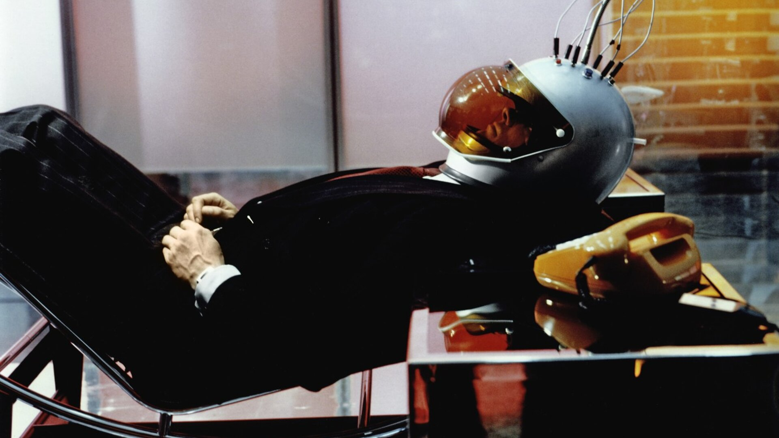
Scanorama's retrospective this year was dedicated to films made for TV, all united by their theatricality.
It was about halfway through watching Rainer Werner Fassbinder’s made for TV epic World on a Wire (1973) in Vilnius' Forum Cinemas Vingis that I was reminded of binging another TV milestone of perhaps even grander allure — the American hit series Mad Men (2007-2015). There are many resemblances between the two that struck me, such as their fugitive protagonists straight out of Hitchcockian spy thrillers.
Most notable however are the giant glass offices in which the characters spend most of their time — simultaneously futuristic and nostalgic. Mad Men’s sets closely mimic 1960’s New York City, but the production design of World on a Wire has a more timeless feel. As in other Fassbinder films, the sets are often so baroque that the characters seem to walk around in some theatrical landscape, almost completely detached from any form of realism.
This theatricality in TV films goes much broader than Fassbinder and is key to many such works made for the medium in the late 20th century. Scanorama bundled seven of those films (including World on a Wire) in their 2023 retrospective, with Ingmar Bergman’s The Rite (1969) being the oldest and Christian Petzold’s Cuba Libre (1996) the most recent.
Dmitrij Gluščevskij, programme coordinator of Scanorama, joined me for a chat in the Forum Cinema Vingis to explain the choices that led to this unusual selection of films. “Our current retrospective about TV and cinema actually derived from a retrospective we did last year, about the relationship between film and theatre, for which we mostly showed cinematic adaptations of plays,” Gluščevskij explained.
“Lars von Trier’s Medea (1988), included in our current programme, serves as a link between them," he went on. " I was irritated how a 'comprehensive' retrospective of von Trier’s feature films in Lithuania didn’t include this film, because it was comprised only of his recently restored titles. And Medea obviously wasn’t a part of that, because it was made for TV, and its rights would present a challenge. So for our programme on theatre we wanted to show people sometimes you have to get off the beaten track. And with Medea in mind, this year’s retrospective feels very logical, because it’s once again about cinema and something it’s often compared to [i.e. TV]."
The programme shows the very diverse ways in which the selected directors used the medium of TV. “The Rite for instance”, said Gluščevskij, “was an attempt by Bergman to do a simpler version of a film production. Because if he wanted to make a theatrical film for cinemas, it would have become an enormous production. Whereas TV was much smaller at that time, and the scope of the film could thus be contained.
“World on a Wire is a completely different story, because Fassbinder was known for his commercial skills and getting funding from all kinds of sources. And when he discovered there was money in TV, he decided to take the leap, because he wanted to make as many films as possible. So every director in the programme approached TV on their own terms.“
With the rise of streaming services, the difference between cinema and small screen productions is rapidly becoming more vague than ever. “Streaming services have become part of the festival circuit, something TV wasn’t part of yet in the late 20th century”, noted Gluščevskij. “So nowadays films made for the small screen look pretty much the same as films shown in the cinema. In our programme it’s often quite obvious that the films were made for TV. They all use the language of television, but in an interesting way. And I think that’s very much related to the theatricality that’s inherent to this retrospective.”
I kept all of this in mind when I went to see The Rite in a small, cosy screening room at Forum Cinemas Vingis. The cinematography by Sven Nykvist was so captivating I wasn’t even bothered to read the subtitles. The unusually ‘flat’ compositions compress the action in the film and somehow made me think of the deliberately anti-cinematic framings of Andy Warhol’s films, even though Bergman and Nykvist are obviously less contrarian to the aesthetics of European art cinema. What unites them with Warhol is that they both managed to find a visual style that works very well on a small screen.
Watching the film left me jealous of the Swedish TV audience in 1969, who got to see it on their huge televisions with tiny screens. But simultaneously I realised I got to experience another form of theatricality that exists outside of the film — the presence of Lithuanian strangers all around me shuffling in their seats. As I felt them gazing in awe or in discomfort at the screen, my own reaction to the film was amplified.... which is ultimately the reason I think it will stick with me for the years to come.
Reviews from the MOVING IMAGES – OPEN BORDERS (MIOB) Third LAB of Cultural, Creative and Festival Journalism

From the European Film Forum SCANORAMA
November 9-19, 2023 in Vilnius, Lithuania

Memory Takes Flight
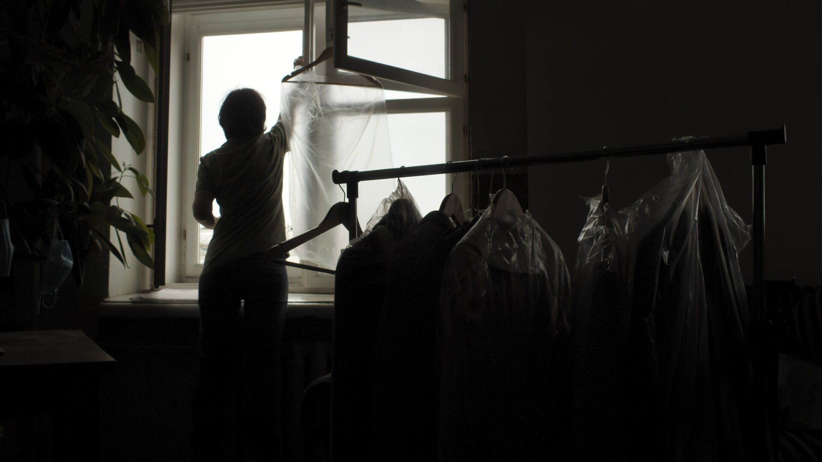
by Rahel Jung
Flickering Super 8 recordings of a little girl open Ptitsa (Poland, 2022). The girl — now a 67-year-old woman — is heard speaking to her own daughter. "Our memory is a nightmare,“ she says later in the film. And yet remembrance seems to be the protagonist`s source of strength; even for the future.
With her first film, Ukrainian painter Alina Maksimenko creates a subtle and personal double portrait of her mother Tatiana and herself. Shown in the section “Glimpses of Europe“ at the Scanorama Film Festival in Vilnius, Lithuania, this 30-minute documentary takes the audience to an apartment in Kyiv during the strict COVID-19 lockdown.
With cinematic sensitivity the director carefully explores the boundaries of human relationships and their wounds. On one hand there is the conversation between Maksimenko and Tatiana, a rapprochement following a period of semi-estrangement a silence. On the other there are phone calls with Inna, whose daughter Katya just died in a motorcycle accident.
Katya was a childhood-friend of the director and the latter searches for consolation in recalling a story from the past. With her documentary, Maksimenko tells the story of finding one way out of the past into the future — and this in a time of pure stagnation. “I think it is time for a change,“ she tells her mother when carefully announcing her wish to move out of the apartment — in which they have lived together for many years.
This everyday life in an exceptional state is depicted by Maksimenko herself in cold but beautifully composed images. Finding a particularity in each frame, her visual language is captivating without being intrusive or over-aestheticised. The absence of a third person behind the camera and therefore an observing human being, seems to contribute to the documentary`s high level of intimacy.
The protagonists might move out of sight or be out of focus: nevertheless their stories, feelings and ways of coping with the difficult situation are always central. And therefore we want to continue seeing Tatiana giving via video-call private piano-lessons and know that the flat's dripping boiler is finally repaired.
Looking back, knowing that this time-period prefaced the arrival of war, there is still hope that Tatiana has found some answers to her "eternal worries." And perhaps the filmmaker could somehow get a little closer to the free-flying birds visible outside the flat's windows which give Ptitsa its title.
Reviews from the MOVING IMAGES – OPEN BORDERS (MIOB) Third LAB of Cultural, Creative and Festival Journalism

From the European Film Forum SCANORAMA
November 9-19, 2023 in Vilnius, Lithuania

How to Smoothly Embrace New Ways… or Not
A review of Four Little Adults
by Rahel Jung
“You`ve given me so much already. Please give me a little more,“ asks Matias (Eero Milonoff) in a prayer to God at the beginning of Four Little Adults. And this is exactly what he gets in writer-director Selma Vilhunen`s romantic comedy about new modes of loving and the struggles that accompany them.
When parish-priest Matias`s wife Juulia (Alma Pöysti) finds out that he is having a serious affair with Enni (Oona Airola), her perception of her perfect marriage is totally shattered. As a last restort, she suggests opening up the relationship and diving into the adventures of polyamory.
Juulia, a rising political star in the Equality Party, exploring the new rules of non-monogamy, is mesmerised by the lip-sync drag performance of American singer-songwriter LP`s track “Lost on you“ by non-binary nurse Miska (Pietu Wikström) and falls in love — later learning that Miska is already in a poly-relationship.
When Enni becomes unexpectedly pregnant by Matias, even the guidebook “The A to Z of Polyamory“ can’t help any more. And while the middle-aged couple`s pre-teen son Miro (Iivo Tuuri) says, unimpressed, “I know what polyamory means“ the four little adults find themselves on a never-ending rollercoaster-ride of romantic entanglements — one where more questions then answers arise.
And even when Matias` mother (Kaija Pakarinen) — the incarnation of the establishment — advices those concerned to abandon their childish behaviour, such a course of action is never an option. But it`s also clear from the beginning that, in the end, everything and everyone will be alright.
This serious-minded and entertaining study of gender, jealousy and generosity is unfortunately not as brave in its realisation as in its ambition. The classy cinematography by Juice Huhtala recalls high-quality TV series; likewise the plot which is fundamentally lighthearted despite all the crying. The story turns in circles and lacks an in-depth analysis of the impact a polyamorous lifestyle has on working environments such as parliament and the church.
The strong performance by Pöysti — who seems to have become the face of Finnish cinema after Tove (Zaida Bergroth, 2020) and Fallen Leaves (Aki Kaurismäki, 2023) — carries the film. However it remains uncertain whether Milonoff`s role is written in a soulless manner or if the fault lies with the performer`s interpretation.
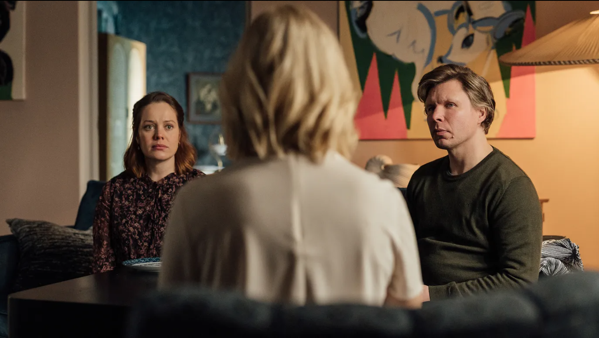
In terms of visual metaphor, the birds which are often seen flying over Helsinki`s rooftops rather straightforwardly epitomise the search for freedom and fulfilment that is pursued in Four Little Adults; Vilhunen suggests that polyamory might be a way to achieving these goals for white, middle-aged, middle-class members of Finnish society.
Reviews from the MOVING IMAGES – OPEN BORDERS (MIOB) Third LAB of Cultural, Creative and Festival Journalism

From the European Film Forum SCANORAMA
November 9-19, 2023 in Vilnius, Lithuania

Review of White Ant (Shalini Adnani, 2023)

A melancholic but lush exploration of belonging and impermanence
by Lucija Furac

What are modernization and land tenure when compared with nature's energy flows and mechanisms of reproduction? The question underlies Shalini Adnani's impressive third short fictional film White Ant (2023) shot on 16mm. Herself of Indian origin, born and raised in Chile and now London-based, the writer-director has woven a melancholic story about belonging and homecoming.

The premise is simple but the revealed state of affairs less so. After the death of his father, middle-aged Asish (Denzil Smith) visits his family home in rural India in the hope of selling it, only to find it infested with insects. The stubborn little ants are well-hidden inside the timber, so a naïve eye — such as Asish's — would easily overlook the danger they pose.
They talk their own Tok-Tokkie, as the termite inspector calls the sounds they produce, and gather in swarms in a nearby meadow at night. Asish catches a glimpse of them one afternoon, or so it appears, as they buzz in an iridescent violet glow outside the house. It must be a dream, however, just like the images of the ants’ movement inside the timber's wormholes. In the depth of the darkness, they shine in vibrant white light, in Brian King's disquieting computer-generated animation.

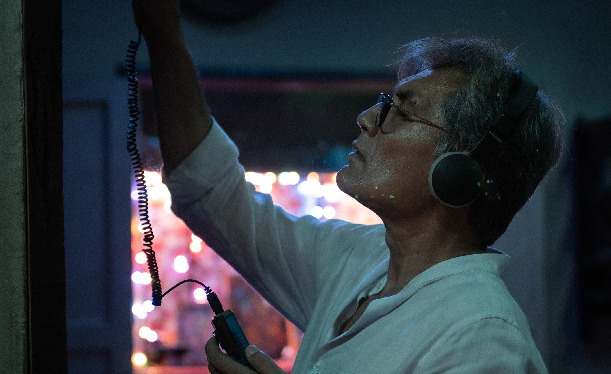
Adnani skillfully balances the tangible and the metaphysical, evoking notions of nostalgia, loss and man’s ultimate inability to conquer nature to its last degree. In the audience’s mind and eyes, the ants may become either a symbol or incontestable physical proof of impermanence. Regardless, White Ant delivers moments of fascinating, lush imagery worthy of witnessing on the big screen.
Reviews from the MOVING IMAGES – OPEN BORDERS (MIOB) Third LAB of Cultural, Creative and Festival Journalism

From the European Film Forum SCANORAMA
November 9-19, 2023 in Vilnius, Lithuania

Essay “Why We Write”
by Lucija Furac

In 1946, English author George Orwell published an essay entitled Why I Write. His case is by no means exceptional. Many people reflect on why they do one thing or another, and many of those who write certainly write about writing itself. One thing is, however, characteristic of Orwell's essay and less characteristic of most personal essays – apart from his own, Orwell also lists every other possible reason to write.
While this may seem to be an impossible task, he asserts that there are in fact only four of them – when writing, one either succumbs to egoism, aesthetic enthusiasm, historical impulse or political purpose. Combinations of these four, Orwell suggests, are also possible.

Discussing contemporary film criticism at this year's Scanorama Film Festival Critics Workshop, the collective agreement among the participants was that the practice seems to have always been in a perpetual state of crisis. There has been no real "golden era" of film criticism, or at least no one ever offered valid arguments for it at the time. Its history has always been riddled with precarity and a lack of definite criteria, and regular prognoses of its demise. How come, then, that we still write?
It seems very convincing that Orwell's four scenarios indeed cover all possible reasons to write, for all time and on any subject. Different smaller reasons probably fall under the umbrella of one of the four main ones. To consider this makes a very amusing thought experiment indeed. Film critics specifically may write in the hope of bearing witness to film history, for example, but not make this intention obvious.
Their motivation may as well be completely mundane, in which they are, like everyone else, not immune to vanity. Without exception, all of them willingly draw attention to themselves by making their views known (hence, a degree of egoism). Often, they write with various theories and causes in mind, defending their own politics. Finally, all criticism is subjective, even when it employs criteria there is consensus about, and there are as many styles of it as there are critics and texts.

I, for one, believe that what gives value to film criticism is precisely its uncertainty. There is freedom in practices that are not limited by definite requirements or expectations. Even when there are conventions, seeing anything in one way or another is ultimately a completely autonomous and self-contained experience – what a joy! And reporting on it, no less so. If one aspect of current film discourse needs to be celebrated, it is the inclusion of an ever-greater number of voices within it.

From all the things one can write about and ask oneself for reasons to do it, little compares to the curiosity of writing about images. Man was made to make images of all kinds and to remain perpetually perplexed by them. Yet even as something is merely to be seen, the ceaseless call to write about it regardless must mean something. Images matter, so does writing about them, an act of ever-lasting discovery of oneself and the world.
Like many of my colleagues, I have many times fallen for images to the point of obsession. Cinema is enchanting in a unique way. It counts on the trust of the audience, it draws one in slyly. Once I started to watch films more consciously and having seen many of them, some of that magic was lost for me. At some point in my early- to mid-twenties, it seemed I went "blind" regarding images, no matter how wonderful they had once appeared to me.
It became hard for me to grasp the depth and value of them, and my relationship to film definitely changed. I did not believe there was anything to see anymore, let alone to say – the world seemed to be separate from the image, apart from it, while the image presented itself almost as a trap: a fraud, incredibly flat.

Thinking about the experience a few years later, it was a period in which I turned away from my selfish reasons to write, to use Orwell's vocabulary. In fact, seeing Aistė Stonytė's new feature-length documentary The Mammoth Hunt at the festival's Kaunas opening night helped me articulate this to myself.
This story about the lost recording of a banned play that Lithuanian director Jonas Jurašas wrote and staged at the city's drama theater in the late 1960s is a story about images that matter beyond an individual, beyond one's personal concerns or pleasure. The 16mm footage which no one was allowed to make but everyone knows exists somewhere, still hidden even in post-Soviet Lithuania, means something for the community and for the history which it wants to tell about itself.
Images can be important in all kinds of ways and in cinema; they often have social significance. Like no other medium, cinema captures collective aspirations and myths, and its imagery is much more than a trifling affair. It can make the masses ponder, or even have access to dangerous things like freedom and change, to explore different uncharted territories, and open dialogues previously unimaginable. The atmosphere in the Kaunas theater during and after The Mammoth Hunt's screening confirmed that to me.

In my grim condition back in the day, it was so much more revelatory to discover the images that did eventually ignite a spark in me: new ones, different and unfamiliar. I am glad that enthusiasm returned in this way, again as something to see but also to write about in a fresh, more nuanced way, previously untried.

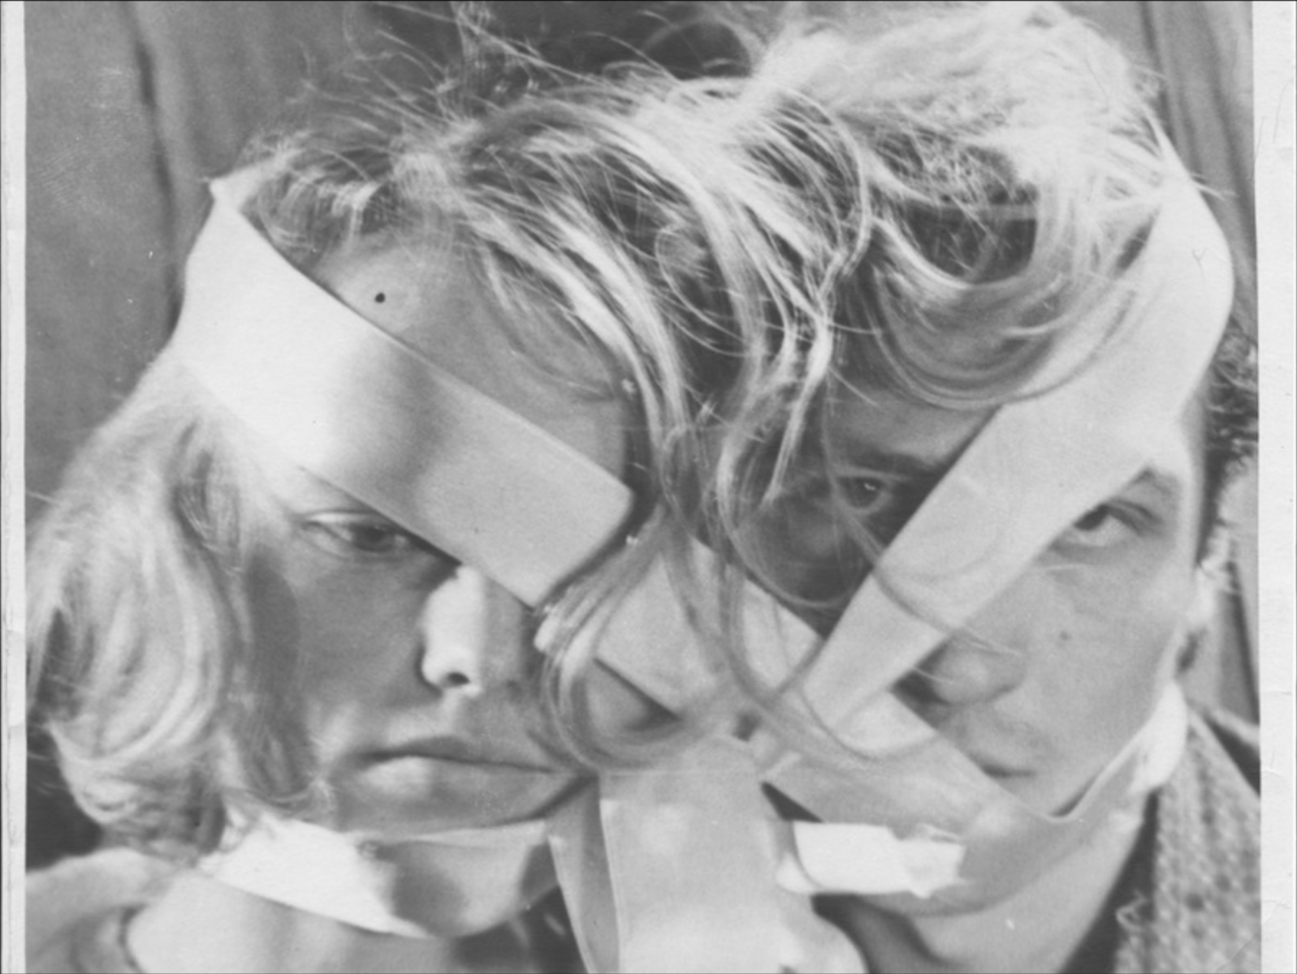
We write because we want to let others know what revealed itself to us. Despite the pricelessness of the images, they do not suffice. We want to talk about them. Our desire for images is never the desire for images themselves. The mind is still curious about something beyond itself and beyond the images, something they hint at – open within us something that both unites us and is greater than ourselves, our aesthetic enthusiasms, historical impulses or political purposes. It appears to me that it is nothing less than life itself.

Reviews from the MOVING IMAGES – OPEN BORDERS (MIOB) Third LAB of Cultural, Creative and Festival Journalism

From the European Film Forum SCANORAMA
November 9-19, 2023 in Vilnius, Lithuania

In the Realm of Images
review by Levan Tskhovrebadze

Cinema, the 1977 gem from the late Georgian writer-director Liana Eliava (1939-2023), is a pure ode to the early motion-picture industry. Deploying vintage vibes reminiscent of silent films and a deliberately naive visual style, Eliava narrates a fictional story about the Georgian pioneer filmmaker Sosiko Cholokashvili (Murman Jinoria). Screened as a retrospective pick during the 2023 European Film Forum Scanorama in Vilnius, Cinema shines as a masterwork which will be a pleasant discovery for Georgian and international audiences alike.

In the early 1900s, new inventions were rapidly changing the world. Trains had already distorted the rhythm of the universe, and now moving pictures were about to question perceptions of time and existence. As the film begins, Sosiko — an inquisitive young man from a noble family — returns home from Paris with a camera bought from the Lumiere brothers' company. His desire to make films imperils his reputation among society, family, and even with his beloved Nutsiko (Ketevan Kobulia). Overcoming any potential embarrassment, the young artists diligently continues shooting, editing, and projecting pictures.

Cinema's aesthetics interweave the early days of Georgian kino with the masterpieces of Keaton, Chaplin, Griffith, and Renoir; Sosiko's appearance even recalls the deadpan visage of Buster Keaton. Our young hero wanders through the streets, capturing random scenes of 1900s Tbilisi daily life, such as the flight of a hot air balloon and traditional dancing. Most of those clips are created by Eliava herself, though we do encounter a few shots from actual pre-WWI Georgian works, such as Journey of Akaki (Vasil Amashukeli, 1912) — the first Georgian feature, of which only 44 minutes now exist.

The picture operates in manner akin to a silent-screen drama, with dialogues relatively unimportant. Many scenes are dominated by the musical score from legendary Georgian composer Giya Kancheli — indeed, one can follow the narrative easily even without an understanding of Russian (Cinema is dubbed in that language) and/or Lithuanian (there were only Lithuanian subtitles during the Scanorama screening).
In the beginning, Sosiko's milieu regards his enthusiasm as a fleeting fad. And, as he becomes more involved in his chosen activity, his circumstances become even more challenging. His uncle, Prince Goga Cholokashvili, drives him from his home; even Nutsiko leaves him, marrying another. Thus the noble gentleman becomes a wandering hobo, the epitome of the tortured filmmaker/artist.

Cinema celebrates the early days of cinematography, telling a story about the destiny of an auteur sacrificing his entire life to produce pictures. The screen glows with sharp black-and-white images, resulting in a dreamy and memorable experience that lingers powerfully in the mind.

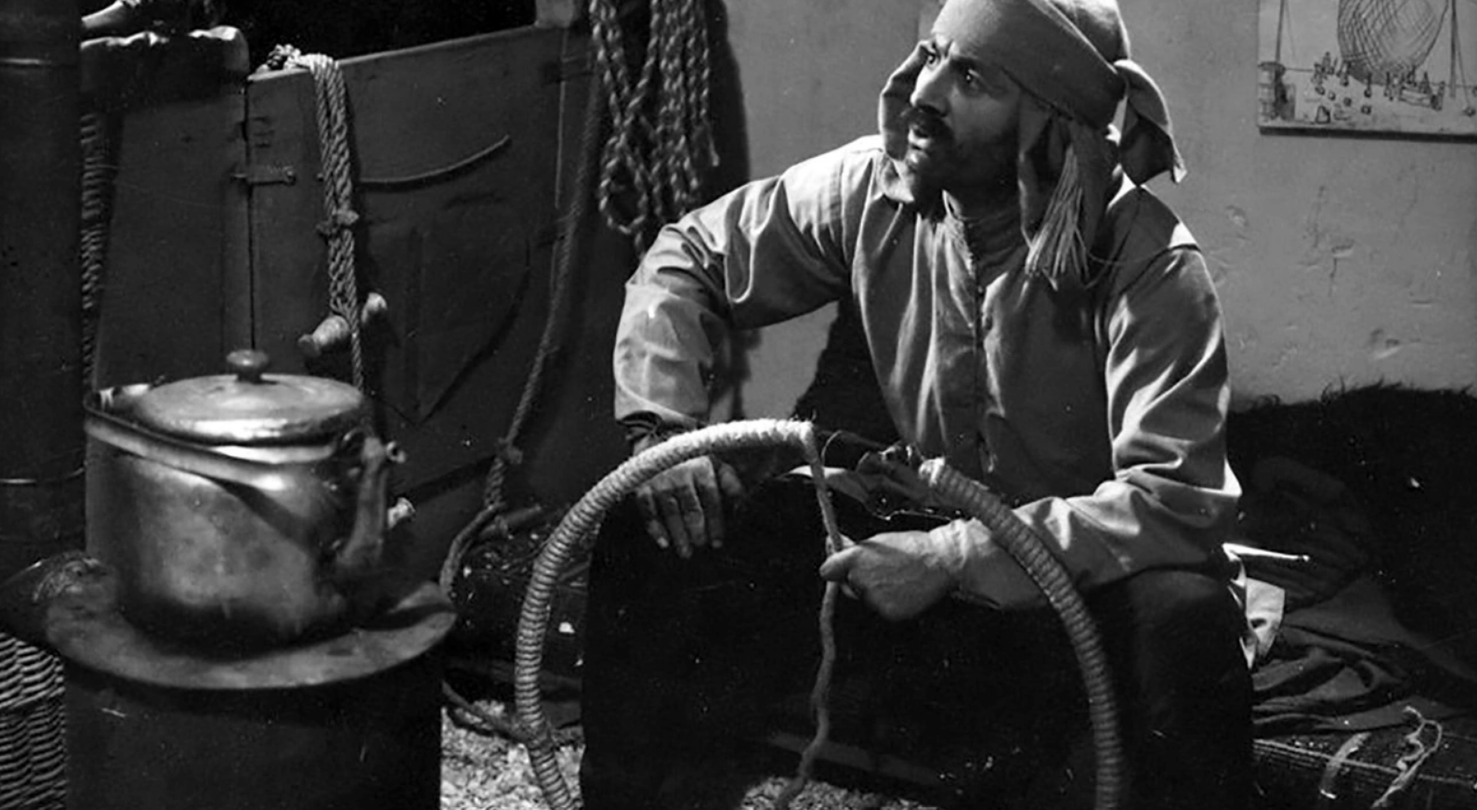

Reviews from the MOVING IMAGES – OPEN BORDERS (MIOB) Third LAB of Cultural, Creative and Festival Journalism

From the European Film Forum SCANORAMA
November 9-19, 2023 in Vilnius, Lithuania

Mammoth Pot-au-feu of Cinema: The Opening of Scanorama 2023

by Levan Tskhovrebadze

The Pot-au-feu (2023) in Vilnius and The Mammoth Hunt (2023) in Kaunas opened the 21st edition of the European Film Forum Scanorama. Promising a diverse selection of films that transcend borders and genres, this eleven day annual celebration of cinema across four Lithuanian cities – Vilnius, Kaunas, Klaipėda, and Šiauliai (with additional screenings in Alytus and Visaginas) – made Scanorama a remarkable event.

Emphasizing the connection of Nordic and Baltic cultures, Scanorama (a contraction of "Scandinavian Panorama") strategically expands the pan-European context. The festival actively honors film history and its future by blending retrospectives with contemporary films – from Lars von Trier's Medea (1988) to Quentin Dupieux's Yannick (2023) to The Rite (1969) by Ingmar Bergman.

Collaborating with six film festivals in Europe dedicated to the continent's cinema, in 2017 Scanorama co-founded the "Moving Images – Open Borders" (MIOB) network. The network promotes diverse artistic facets, regional characteristics, and socio-political narratives of European cinema.
Both of the opening films featured wide-ranging artistic elements and socio-political accounts of European culture. The Mammoth Hunt by Aistė Stonytė searches for the mysteriously lost film recording, and the stories around it, of a play by renowned Lithuanian theatre director Jonas Jurašas. Tran Anh Hung in The Pot-au-feu meanwhile attempts to convey the passions of fictional 19th century gourmet Dodin Bouffant on screen.

Scanorama in Vilnius opened with a lot of food served at a reception in the multiplex Forum Cinemas Vingis, followed by Tran's gastronomical treat. Adapting Marcel Rouff's 1920 novel The Passionate Epicure, the director engages the audience in a flavorful experience. Dodin Bouffant (Benoît Magimel) is living in culinary paradise, tasting, inventing and reinventing toothsome meals with the cook Eugenie (Juliette Binoche) – with whom he happens to be in love.
Dodin Bouffant's admiration of Eugenie comes from her exceptional kitchen skills. He's in love with her food more than the woman herself, so the director attempts to convey that feeling to the audience exhibiting closeups of tempting delights. Besides this sensory aspect, The Pot-au-feu is an exquisite story about love and loss. The picture is as delectable as the dishes displayed, making it a feast for cinema and cuisine enthusiasts alike.

The Mammoth Hunt tells the story of Jurašas, whose play of the same title was banned from stages in the late 1960s by the Soviet authorities. The movie features numerous important Lithuanian artists – from directors to actors to cinematographers – and overall presents a petrifying but ultimately joyful celebration of artistic resistance. At the Kaunas opening, one could spot many honorable and renowned Lithuanian artists from both the cinema and theater fields – and even the country's esteemed former president and "father of the nation," the 91-year-old Vytautas Landsbergis.

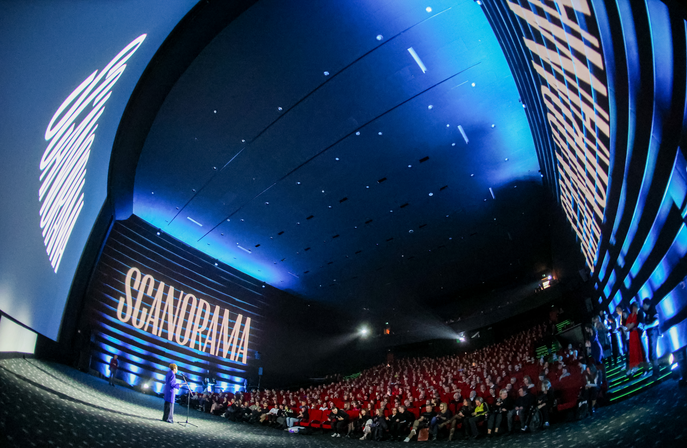
The review was written during the Moving Images – Open Borders (MIOB) 3rd LAB of Cultural, Creative and Festival Journalism.

Reviews from the MOVING IMAGES – OPEN BORDERS (MIOB) Third LAB of Cultural, Creative and Festival Journalism

From the European Film Forum SCANORAMA
November 9-19, 2023 in Vilnius, Lithuania

Review: Medea (1988). Waiting for the Tide to Rise

by Andy Stoeva

Lars von Trier’s Medea dives into an ocean of despair only to resurge in an emotional tsunami, capable of rendering the viewer speechless

O Medea, in what a hopeless sea of misery heaven hath plunged thee…
– Euripides, Medea
This year’s Scanorama program submerges us into Medea (1988), a lesser-known television film by Lars von Trier that is not necessarily a must-see on the big screen but a must-see nonetheless.
It is a rare opportunity to be able to watch such partly forgotten made-for-TV masterpieces, so the festival's retrospective – which also includes films by Ingmar Bergman, Jean-Luc Godard, Agnès Varda and Rainer Werner Fassbinder – comes as a welcome surprise. Von Trier’s 1988 take on the eponymous mythological figure addresses themes of womanhood, sacrifice, pride and desire in a somewhat loose retelling of the legend.

Trier pays homage to Danish filmmaker Carl Theodor Dreyer’s script (based on Euripides’ play of the same title), specifically addressing this origin in the opening credits. While von Trier uses Dreyer’s text as a starting point, he develops his own interpretation of the Greek classic, centered on the story of Medea (Kirsten Olesen). Set immediately after Jason (Udo Kier) has abandoned her to marry Glauce (Ludmilla Glinska), daughter of King Creon (Henning Jensen), the film chronicles Medea’s revenge after she hears of her banishment from Corinth.

The result is an eerie tale of love and betrayal, overflowing with water metaphors and delivered through a 77-minute delirious dream, at times visually reminiscent of Tarkovsky’s Mirror. Lighting and color make a considerable contribution to the artistic impact of the film, alternating between cold and warm and adding a certain metaphorical implication to the setting, dialogue lines and characters’ relationships.

The director leaves us room to breathe, giving us time to enjoy many of the images, much like contemplating a painting. In both the visuals and the sound design there is an occasional deployment of distortion and exaggeration. The frequent use of green-screen effects gives Von Trier and cinematographer Sejr Brockmann room for experimentation with size and dimension.
An example of this approach is when Medea delivers one of the most impactful lines in the film: “Why must women bear so much, wordlessly submissive in body and deed?” We can see her two children sleeping in the background, appearing much larger than the main character herself – thus foreshadowing the tragic ending.
Moreover, the dialogue level often does not correspond to the distance and positioning of characters, animals and objects. Von Trier intentionally accentuates only what is important to the story in order to convey this ominous aura of the film.

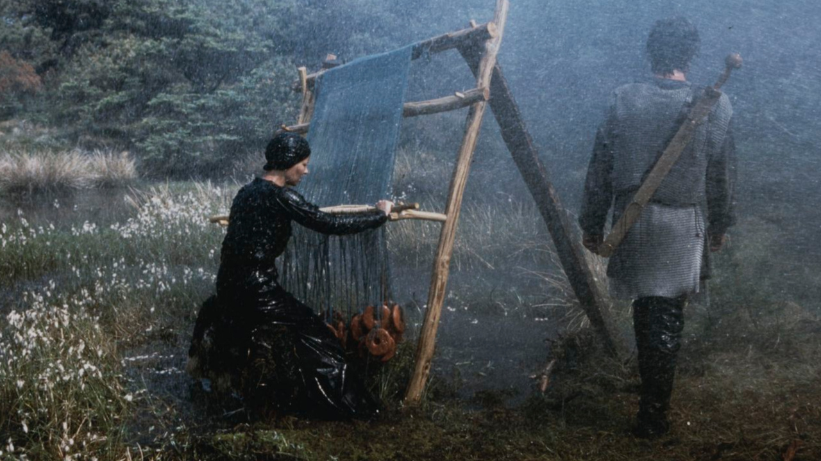
The inevitably grim finale leaves the viewer gasping for air, drowning in suspense despite the familiarity of the ancient myth. The tragedy is equally mesmerizing and devastating – much like the protagonist we are left on the shore, waiting for the tide to turn and take us to a safer place. Nevertheless, we find ourselves reluctant to let go of Medea’s masochistically enjoyable feeling of unease.

Reviews from the MOVING IMAGES – OPEN BORDERS (MIOB) Third LAB of Cultural, Creative and Festival Journalism

From the European Film Forum SCANORAMA
November 9-19, 2023 in Vilnius, Lithuania

Away from the Spotlight

by Andy Stoeva

Anthony Ing’s compilation short Jill, Uncredited reveals surprising philosophical undertones
We often wonder how many strangers have accidentally captured us in the backgrounds of selfies, pictures of tourist-attractions and group photographs. If we could get hold on a collection of these images — an archive of some sort — would it only scratch the surface of our lives, or would it actually capture an element of our essence?

Such questions arise while watching Anthony Ing’s Jill, Uncredited (2022) — and while we could never possibly know about every single picture of us that exists, this is not quite the case with Jill Goldston.
Known as the most prolific "extra" in British film and television, the actress has appeared in over 2,000 projects. Her enormous body of work includes myriad cameos and walk-ons on the big and small screens; but Goldston herself admits she has never wanted to be a star.
This idea of willingly keeping away from the spotlight may spark philosophical explorations, especially in terms of our daily lives. As we watch the 18-minute UK-Canadian production we contemplate the notion that our presence is not valuable solely in the forefront of things.
Ing’s compllation of clips showcases Goldston’s work, underlining the importance of the unnamed characters who otherwise fade into the background — and the viewer also realise that film and television productions would often be impossible without their contributions.

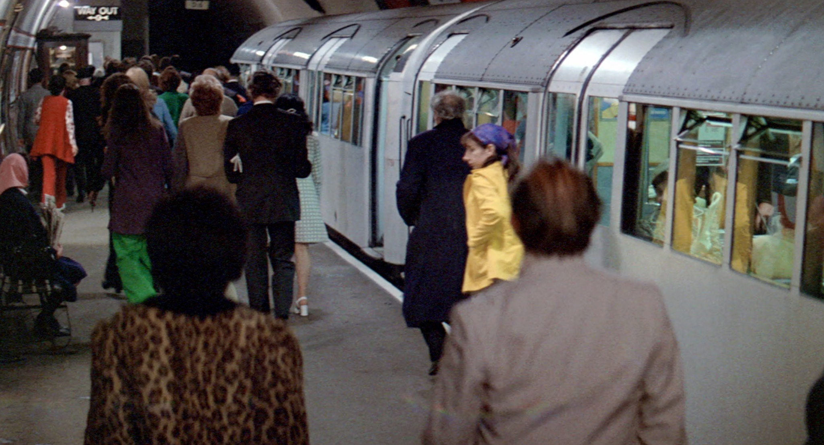
Jill, Uncredited is arguably not a "documentary" in the narrowest definition of the term; it is more of a film-essay, due to the way it withholds much information — implicitly challenging us to discover more about the topic by ourselves.
Despite its non-narrative nature, the film somehow retains a feeling of suspense – in each frame and scene we find ourselves in a constant game of "Where's Waldo/Wally?" We keep our eyes peeled for the passer-by who has now, thanks to Jill, Uncredited, turned into a main character – and perhaps it might even be us…

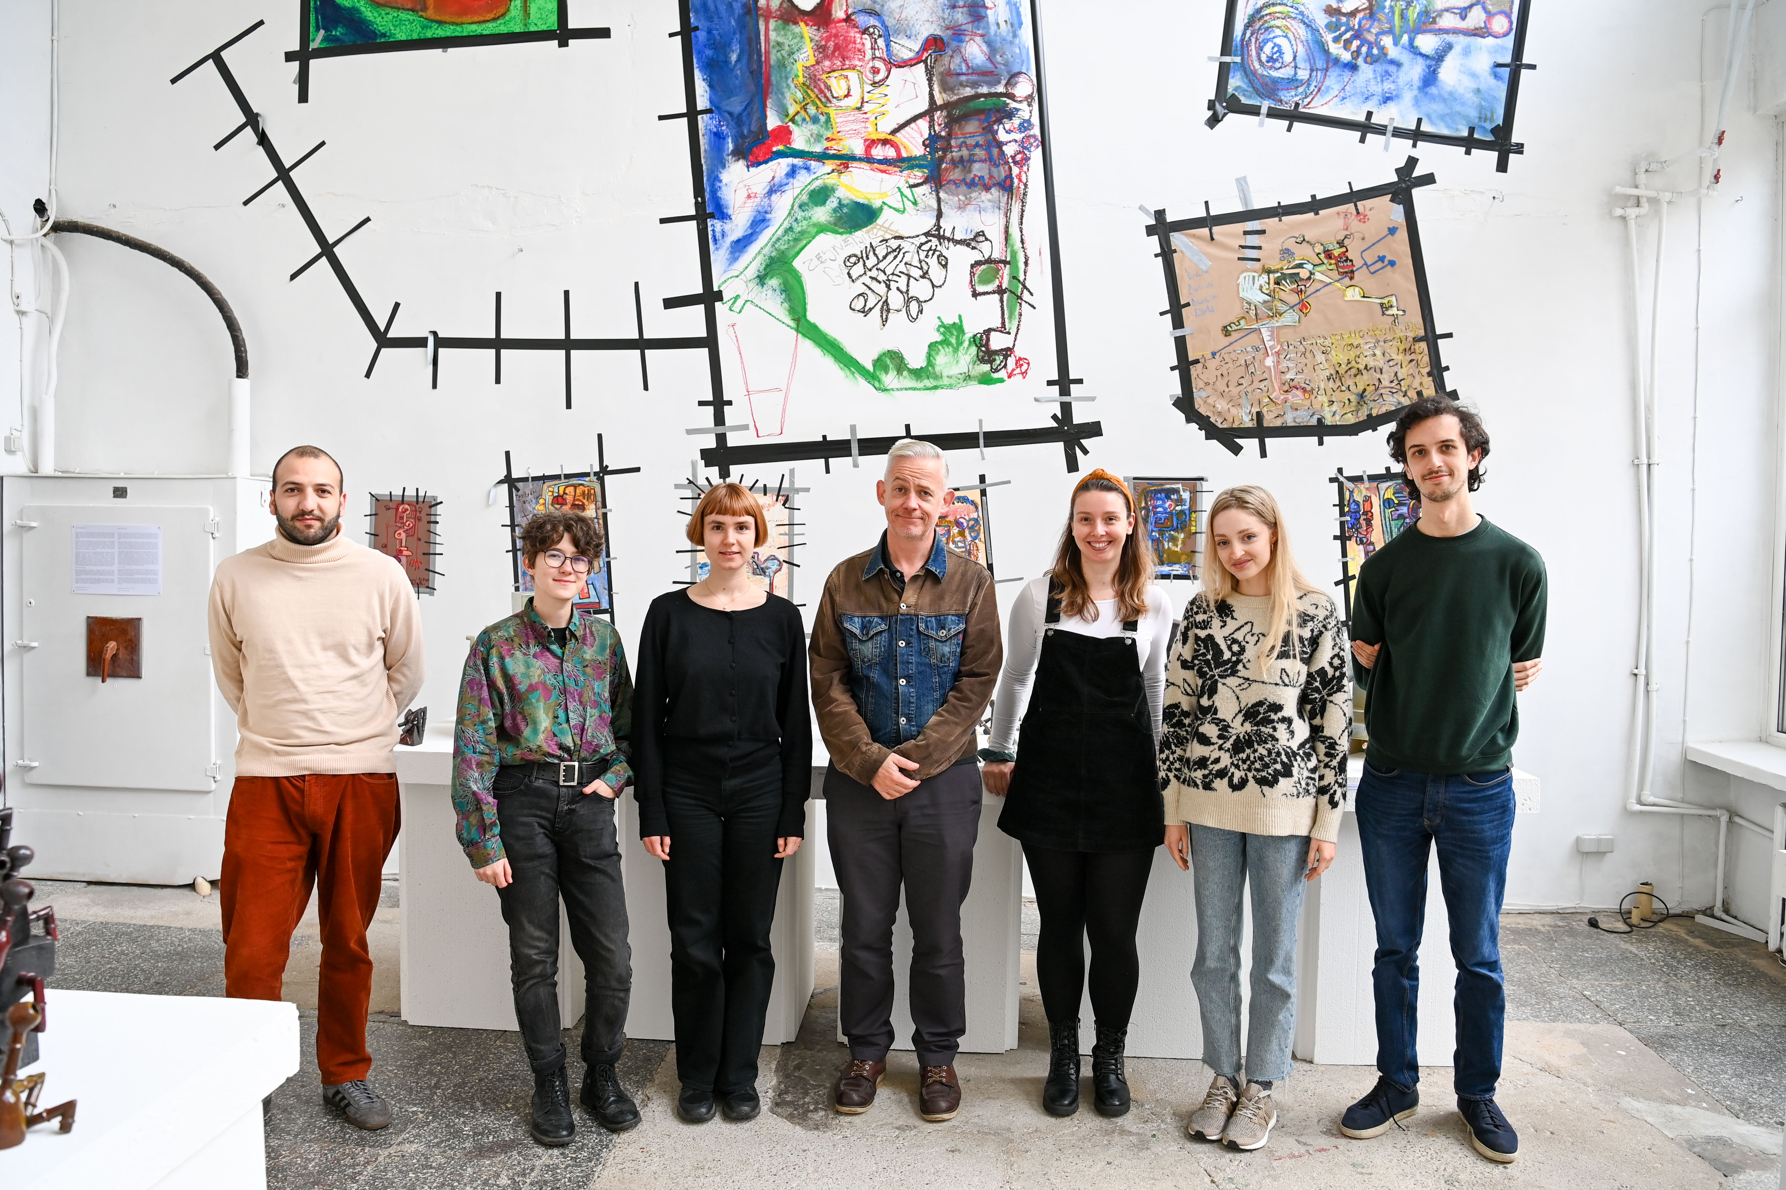
ADDITIONAL INFORMATION:

Goda Januskeviciute
Moving Images – Open Borders (MIOB)
European Film Forum SCANORAMA
+370 610 34427
info@miob.info

